Behavior personalized Adaptive Cruise Control using Probability-Weighted ARX model

Range saturation to simulate radar max range.
- Show the ability of the PrARX for GlvACC,
- show the implementation platform, show the results
- show the limitations of Glv ACC (quick with GHR)
- compare with IDM and Gipps (quick)
- expose the fact that possibility of fuel consumption calculation
- open on the possibility to optimize models on FC.

- Introduction
- Ghost vehicle ACC concept

In this first section, the concept and the macroscopic architecture of the integrated adaptive cruise control model are presented. The concept behind this model is to create a simple structure able transform any vehicle following model in an ACC. The goal being to take advantage of the large variety of already created following models, and to propose and architecture that can run online in a modern car. Most of the vehicle following models have been created for traffic flow modeling or human driver behavior comprehension. The focus of this paper is made on the second type of model, enabling more precise and user adapted vehicle dynamics reproduction, while keeping computation time very low. Nevertheless, to prove the flexibility of the presented ACC model, its implementation with a microscopic flow model is also presented in section ??.

As a clever cruise control system, ACC systems have to be able to deal with two main situations. Cruising at constant velocity when there is no leading vehicle in the way, or follow a leading vehicle with the right safety distance. Moreover an ACC must be able to handle correctly transition phases. The aim of the presented model is to be able to turn any vehicle following model into an ACC model without bringing any modification. Thus the vehicle following model needs to see a leading vehicle at any time.
To be able to tackle this issue, the concept of ghost leading vehicle (GLV) is created. The ghost leading vehicle replaces the real leading vehicle (RLV) as soon as the real leading vehicle following conditions are not satisfied. The ghost leading vehicle (GLV) is driven at the cruise control desired velocity, and a set of GLV/RLV switching rules enable to change the leading vehicle smoothly, enabling the following vehicle (FV) to have the ACC functionality.

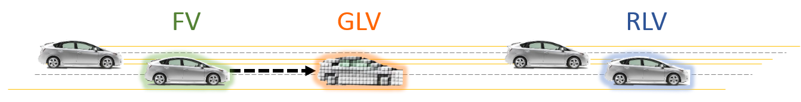
Figure 1: Two lanes highway driving. The FV is following the GLV.

The retained approach has been to use the following model to follow both the GLV and RLV at any time. Then based on the GLV, RLV, and following model outputs, the switching mechanism can decide which target velocity the FV has to run. The following rules used to switch from one situation to another only works with sophisticated enough following models. Indeed the following model inputs must have natural reaction to the distance and relative distance between vehicles.
In this configuration, two main situations and four switching cases can occur. The two main situations have already been exposed: following the ghost leading vehicle (GLV) or following the real leading vehicle (RLV). The GLV following situation is the basic state when the ACC is activated. The GLV is at first generated at the point of non-acceleration of the following model.
Then the four possible switching situations are the following:

- Soft RLV in
This switching case modifies the situation from following the GLV to following the RLV.
“Soft RLV in” expresses the fact that while following the GLV, a slower than GLV and far away RLV vehicle is in the current lane. After a certain time, this RLV will overlap the GLV and eventually collide the FV.
To avoid this situation, both following models output for the RLV and GLV are constantly computer, and when these model outputs (here acceleration) intersect, the transition from following GLV to RLV is done.

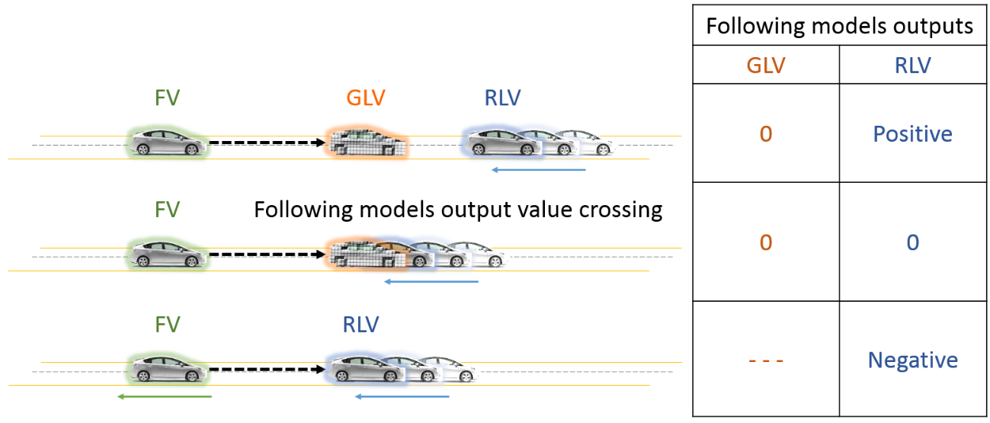
Figure 2: “Soft RLV in” situation. The RLV is slowing down, and is smoothly replacing the GLV, when the model’s output (FV acceleration) values signs cross.

- Soft RLV out
This switching case modifies the situation from following the RLV to following the GLV.
“Soft RLV out” expresses the fact that while following a RLV, the RLV accelerates up to the ACC desired velocity. When the RLV reaches the cruise control desired velocity, the RLV is replaced by an overlapping GLV. Another switching possibility is to virtually superpose the RLV and GLV, but force the GLV velocity to the ACC velocity for the following model output calculation. Then the transition can be triggered with the same technic than for “Soft RLV in”, with following models output values crossing.

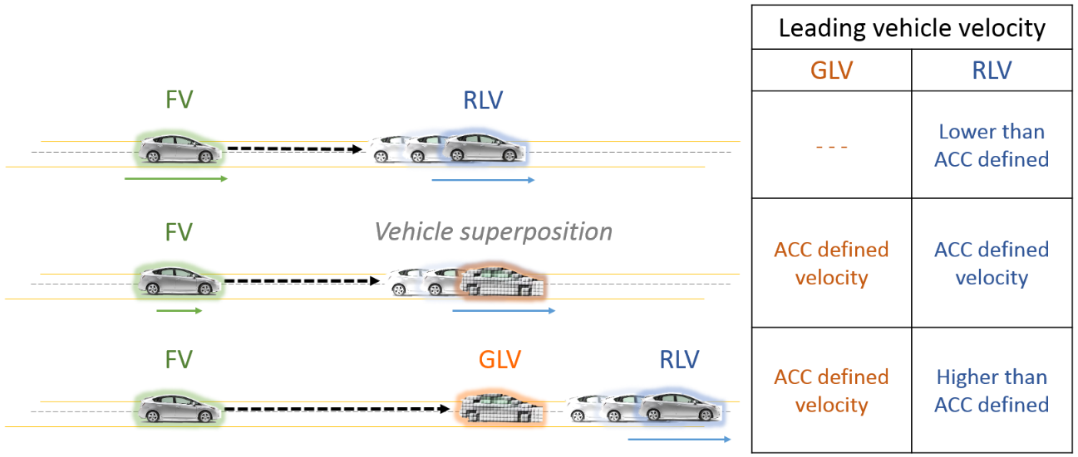
Figure 3: “Soft RLV out” situation. Method 1. FV is following RLV. RLV accelerates. When RLV velocity is higher that the cruise control desired velocity, the RLV is replaced by the GLV.

- Hard RLV in
This switching case modifies the situation from following the GLV to following the RLV.
“Hard RLV in” expresses the fact that a RLV inserts between the FV and the GLV, and its velocity is low enough so the driver would need to brake. In that case, output of the following models are switched in a time corresponding to a fourth of the initial headway time, to avoid any safety related issue while avoiding acceleration discontinuity. The output switch occurs only in the replacing following model output value is lower than the previous one.

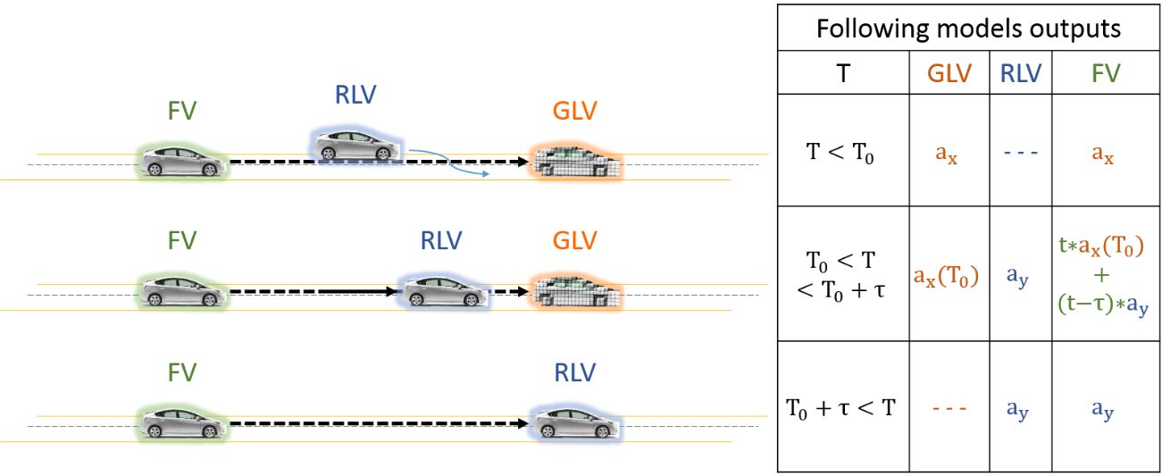
Figure 4: Example of a possible “Hard RLV in” situation. Here the previously following vehicle was the GLV and a RLV inserts with a low differential velocity. $a_{x}$ has to be lower than $b_{x}$ to trigger the “Hard RLV in situation”.

- Hard RLV out
This switching case modifies the situation from following the RLV to following the GLV.
“Hard RLV out” expresses the fact that while following the RLV, this vehicle disappears from the current lane (lane change, highway exit …). The RLV is replaced by the GLV. The GLV velocity is increased from RLV velocity to the cruise control desired velocity with an acceleration corresponding to the average observed driver acceleration during learning phase.

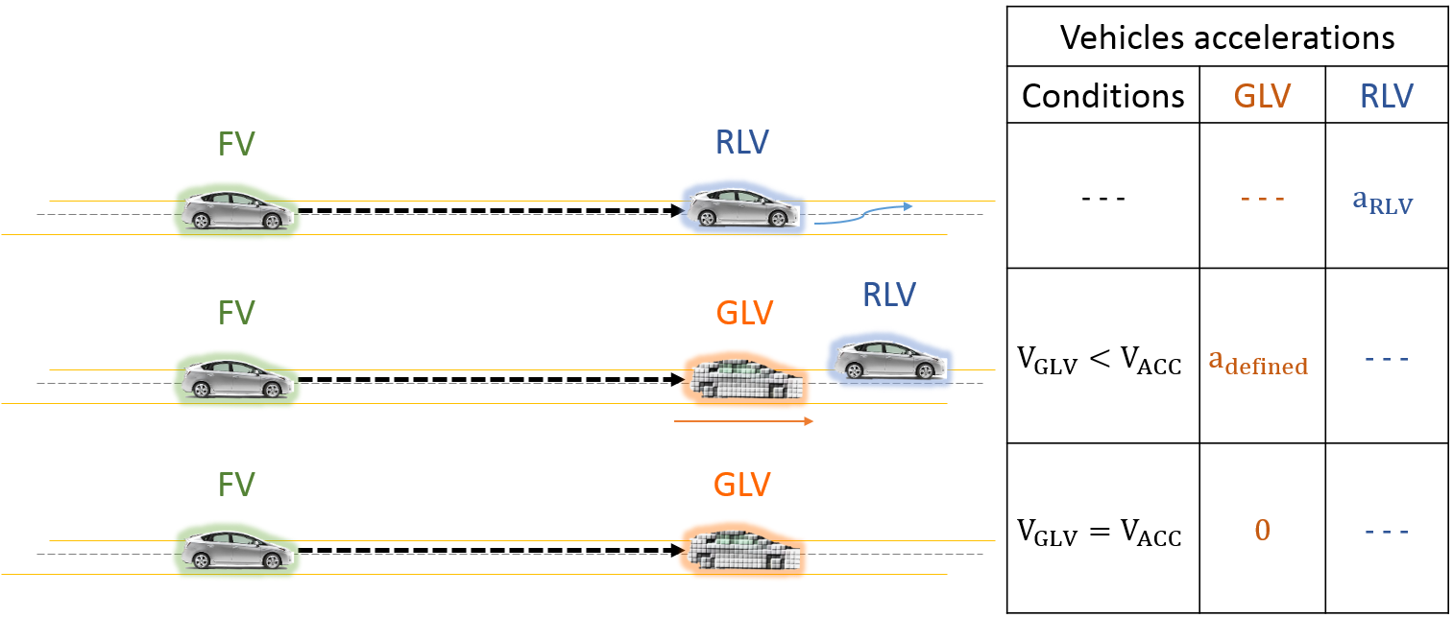
Figure 5: Example of 'Hard RLV out' situation.

The exposed switching contiditions are only one possible interpretation of the model. These conditions have shown good results with machine learning models, but can be too broad for some classic can following models.
This Ghost Leading vehicle base ACC model will be named Glv-ACC in the rest of the paper.

- Glv-ACC implementation
This section is dedicated to the understanding of the structure of the model from the point of view of the implementation. Simulink has been used to build the model. It enables easy switching of the vehicle following model, and the connection to the vehicle simulation software IPG Carmaker is done with this interface.

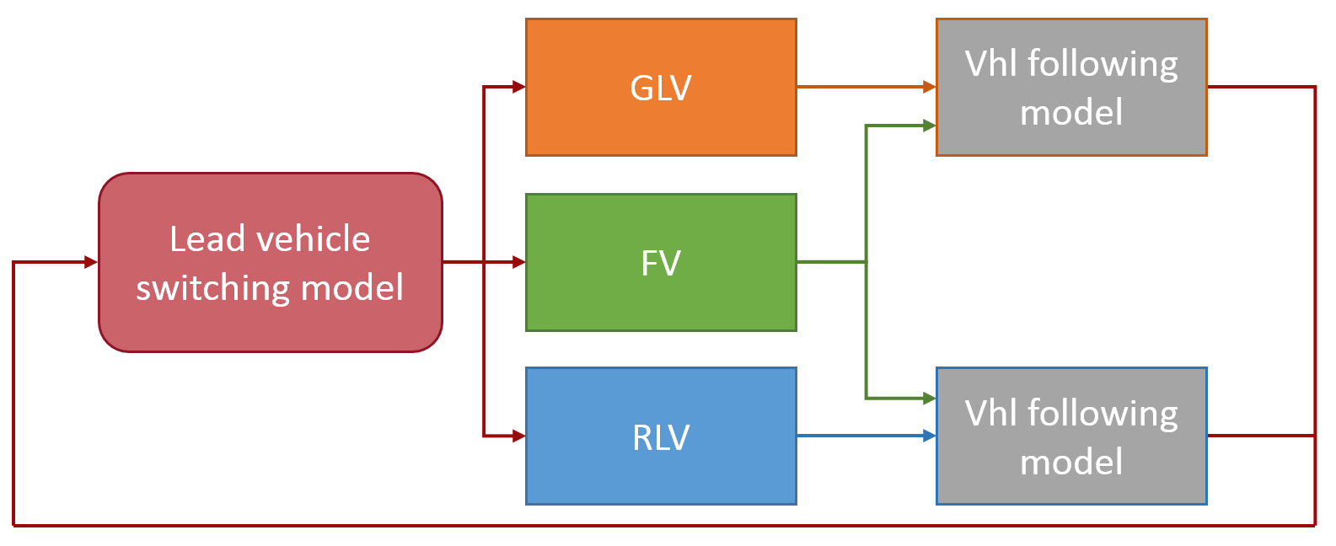
Figure 6: Macroscopic model diagram.

As explained in I, the Glv-ACC runs two instances of the selected vehicle following model in parallel. This is required to be able to have smooth mode switching in case of “soft RLV in”. This transition condition is based on both following models output comparison. On Figure XX, the upper and lower vehicle following branch use the same following model. Only the input are different.
The upper branch is dedicated to the GLV. The Ghost Vehicle bloc is able to generate the GVL based on the desired cruise control velocity, the initial relative distance to the following vehicle, or the actual position of the RLV. The initial relative distance is optimized a priori to enable no acceleration at the vehicle following model output.
The lower branch is dedicated to the RLV. On a real world situation, the RLV information would be extracted from on vehicle sensors like a Radar, Lidar or camera system, and the flow vehicle information could be communicated to the following model. In our simulation case, the RLV position is read from a vehicle position file.
The following figure shows the Simulink implementation of the following model.
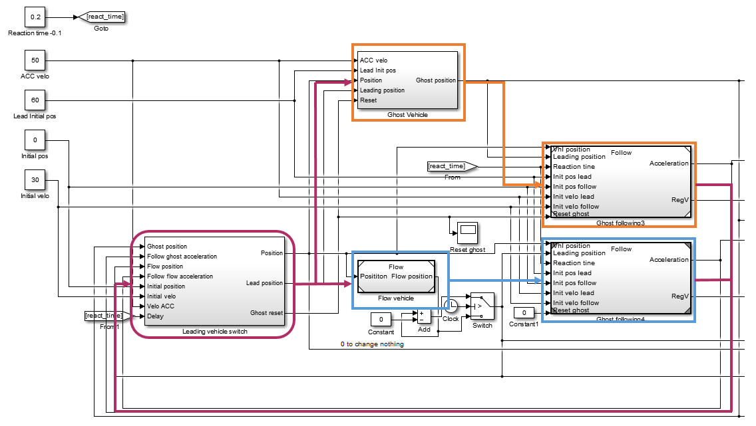
Figure 7: Example of Simulink integration of the model.
Here is the pseudo-code of the switching logic:

At first the current case choice based on the evaluation of the actual situation.

Initializing as Last_case = “Following GLV”

SWITCH Last_case
CASE “Following GLV”
IF (Discontinuity in RLV_velocity) AND (Follow_RLV_acceleration < Follow_GLV_acceleration)
Current_case = “Hard RLV in”
ELSEIF (No discontinuity in RLV_velocity) AND (Follow_RLV_acceleration < Follow_GLV_acceleration)
Current_case = “Follow RLV”
ELSE
Current_case = “Follow GLV”
END
CASE “Follow RLV”
IF (No discontinuity in RLV_velocity) AND (Follow_RLV_acceleration > Follow_GLV_acceleration)
Current_case = “Soft RLV out”
ELSEIF (Discontinuity in RLV_velocity) AND (Follow_RLV_acceleration => Follow_GLV_acceleration)
Current_case = “Hard RLV out”
ELSEIF (Discontinuity in RLV_velocity) AND (Follow_RLV_acceleration < Follow_GLV_acceleration)
Current_case = “Hard RLV in”

ELSE
Current_case = “Follow RLV”
END
CASE “Hard RLV in”
IF timer>transition_time
Current_case = “Follow RLV”
ELSE
Current_case = “Hard RLV in”
END
CASE “Hard RLV out”
IF case_done_flag == 1
Current_case = “Follow GLV”
ELSE
IF (Discontinuity in RLV_velocity) AND (Distance_to_GLV < Distance_to_RLV)
Current_case = “Hard RLV in”
ELSEIF (No discontinuity in RLV_velocity) AND (Follow_RLV_acceleration < Follow_GLV_acceleration)
Current_case = “Follow RLV”
ELSE
Current_case = “Hard RLV out”
END
END
OTHERWISE
Current_case = “Follow GLV”
END

Then the program realise the action corresponding to the case:

SWITCH Current_case
CASE “Follow GLV”
The ACC uses the GLV following model to drive the FV.
CASE “Follow RLV”
The ACC uses the RLV following model to drive the FV
CASE “Hard RLV in”
The follow model output is linearly changes from the last output to the RLV following output in a duration corresponding to the fourth of the headway time.
CASE “Hard RLV out”
The GLV velocity will be progressively modified from the last RLV velocity to the ACC desired velocity with an acceleration corresponding to the average driver acceleration observed during the learning phase. The GLV following model is used to drive the vehicle during this phase.
END

- PrARX car following model

The first following model used in the ACC system is the PrARX model. This model enables the reproduction of the dynamics of the Vehicle/Driver entity. Thus, we do not have to model the vehicle itself. The real vehicle can be controlled from the desired acceleration, velocity of position output of the ACC model with an independent control loop.

Vehicle control explanation diagram
The personalized vehicle following behavior algorithm is based on the Probability-Weighted ARX (PrARX) model [12]. The idea is quite similar to Piecewise affine autoregressive exogenous (PWARX) models, which is an expression of hybrid dynamical systems. PWARX models have discrete mode switching, however, PrARX introduces soft mode switch based on probability estimation. This avoids discontinuity in the model output during mode transition. PrARX models also allow parameter estimation in an adaptive manner, which opens the possibility to a progressive revision of the following parameters depending on the user’s behavior modification. Nevertheless, the level of sophistication of this model also leads to more difficult parameter identification and the model stability analysis is quite delicate.

Definition of the model

The PrARX model is composed of ARX models weighted by parameters expressing the probability of the presence in a mode. Thus the PrARX model can be defined by:

$$f_{PrARX}\left(r_{k}\right)=\sum_{i=1}^{s}{P_{i}θ_{i}^{T}φ_{k}}$$

where $r_{k}∈R^{n}$ defines the regressor vector (input vector), $φ_{k}={[r_{k}^{T} 1]}^{T}∈R^{n+1}$, $θ_{i}^{T}∈R^{\left(n+1\right)*q} (i=1,…,s)$is the identified vectors defining the $i^{th}$ ARX modes, $s$ defines the number of modes, and $P_{i}∈R^{q}$ is the vector expressing the mode probability of the $q$ outputs. $P_{i}$ is defined by the following softmax function:

$$P_{i}=\frac{exp⁡(η_{i}^{T}φ_{k})}{\sum_{j=1}^{s}{exp⁡(η_{j}^{T}φ_{k})}}$$

$$η_{s}=0$$

where $η_{i} (i=1,…,s-1)$ is the identified parameter defining the probabilistic partition of the different modes.

Details of the identification algorithm are available in エラー! 参照元が見つかりません。.

To insure the reliability of the parameters estimation, we have to modify the identification algorithm of the PrARX model. Instead of fully relying on the mode-clustering and ARX-modes simultaneous identification, we supervise the original clustering of the data. The regressor vector data is separated in a set of sub-data depending on the desired mode separation. From this data, we calculate a first set of mode separation parameters using multinomial logistic regression, and then some mode parameters are computed in a few iterations. The solution is not converged, but gives a first approximation of the mode separation parameters matrix Eta, and of the ARX-modes parameters Theta. Once this operation complete, we have initial parameters and we run the full parameters identification process, involving mode-separation parameters and ARX-modes parameters optimization in a simultaneous operation. This process enables increased output fidelity while keeping the freedom in the mode separation. By this way we hope to correlate as much as possible to the driver’s driving intensions.

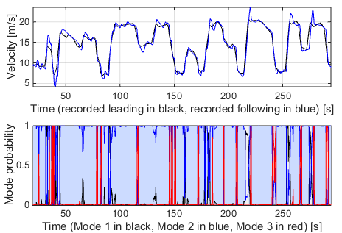
Figure 8: Example of clustered data

- Driver classification (COMS measurements)

With the goal of being able to describe in a realistic manner the behavior of different users, we ran a measurement experiment involving different users in a small electric vehicle. The used vehicle is a COMS (Toyota Autobody Corporation), full electric vehicle designed for urban personal mobility and delivery purpose (see Figure 2). We equipped the vehicle with on-wheel velocity sensors, GPS tracking, steering and pedal operation sensors, and video cameras. Velocity sensors are composed of quad edge detecting optical sensors, an encoder is used for steering sensor, and pedal operations sensors were created with linear potentiometers. These analog and digital signals are measured on a PLC, which communicate with an on-board mini PC by Ethernet. The GPS sensor and the video camera are directly connected by USB port.
Measurements are then recorded in a PC, at a 100Hz frequency. This high frequency enables filtering possibilities.
We conducted an experiment involving 5 users for 1 hour each with 3 different exercise types, in a residential area, enabling the most natural driving situation possible with the electric vehicle. Drivers had to drive by themselves, or follow a leading vehicle depending on the activity. The information we could gather during this experiment was used to select the best candidates for the driving simulator sessions.

- Driver measurements in Driving Simulator

To be able to exactly control the desired velocity pattern of the leading vehicle, we decided to also conduct experiments in a Driving Simulator. The driving Simulator is composed of a real vehicle interior, and the visualized image is created with 3 wide video-projected screens. This configuration enables 180 degree vision, and gives good driver immersion. Vehicle dynamics is calculated by the use of Carsim (Virtual Mechanics Corporation), and the environment represents a typical a four lanes highway. The implemented velocity patterns represent high and low congestion situations on this road.
Based on the driver measurements, we selected two typical candidates for each measurement. One representing typical “aggressive” driving (high accelerations, more oscillatory behavior, short headway distance), and a driver representing typical “soft” behavior (low accelerations, long headway distance).

Show drivers velocities [2x1]

- Inputs, output, and mode separation choice

Reproduction of the driving behavior depends not only on the structure of the model (here PrARX), but also on the selection of explanatory variables of the model. Some parameters can be related to the environment (e.g. condition of the road, traffic congestion, weather condition), some other depend on the vehicle dynamic state (e.g. velocity, acceleration, distance between vehicles, relative velocity between vehicles), and finally some depend on the driver himself (e.g. fatigue, aggressiveness, cognitive load). Some indicators have been developed to try to express some feeling of the driver [8] (KDB [9], PRE (Perceptual Risk Estimate) [10]). These indicators are commonly used to trigger emergency systems (e.g. emergency braking), but are more difficult to use in the case of behavior reproduction.
The selected input vector is composed of acceleration of the driven vehicle, distance between the driver and leading vehicles (range), relative velocity between the vehicles (range-rate), and the inverse of the headway time (velocity/range) [11].
This set of inputs enable to give vehicles dynamic information and surrounding vehicles relation characteristics.
The output of the model is the desired acceleration of the vehicle.
A delay of 300 ms is applied between the input and the output of the model, to insure a cognition time matching the average human brain capacity [8].
Mode pre-selection has a major role in the identification process of following behavior. We selected two different pre-clustering methods, which lead to two different closed-loop vehicle behavior. In both cases we chose to do 3 modes clustering. 2 modes for special events, and 1 main mode for the rest of the driving.

The most safety oriented clustering (Case A) is:
A mode for the 20% most negative accelerations, a mode for the 15% highest accelerations, and the last mode for the rest of the data. This combination gave us a more stable and safe result from the driver point of view.

A better vehicle dynamics reproduction clustering (Case B) is:
A mode for the 15% most negative range-rate cases, a mode for the 20% highest range-rate values, and the last mode for the rest of the data.

- Following model results

Two initial mode clustering cases have been defined in the previous section. The results in terms of calculated outputs are available in Figure 4.
We used the previously mentioned cases to calculate the open-loop following model output (we use the original measured regressor vector as an input vector), and we also calculated closed-loop output of the following model by integrating the model output. The delay due to the driver has been set to 300ms, and the model is computed at 10Hz.
In Figure 4, the black lines represent the values recorded in the Driving Simulator experiment. The blue lines represent the open-loop simulated output. Due to the lack of feedback in the open-loop simulation, we did not integrated the output of the model to get the range, range-rate and inverse of headway-time. The integration of the open-loop acceleration would only show integration of the identification error. The green lines represent the output of the closed loop model.
In both cases we can observe the accurate model prediction compared to the recorded pattern in terms of velocity and acceleration. Moreover, range-rate and range are very well preserved, and mostly conservative in value. This conservative behavior is very important for the confidence feeling of the driver. We can observe that the model tends to act like a low pass filter, avoiding undesirable oscillations, but keeps a good response dynamic when range correction has to be done.
As explained in the previous section, Case A, which uses acceleration based pre-clustering, enables a safer ride for the passenger by keeping a larger minimal range between vehicles.
On the other hand, the range-rate based pre-clustering (Case B) tends to reproduce more accurately the driving behavior of the user, but can be less safe.
The use of one or the other will mainly depend on the usage of the driver model. For the ACC, Case A seems to be more useful. It is then possible to transform the following model in an ACC model by the technic of the ghost leading vehicle explained in Section 2.
Moreover, Case B can also be used to verify the accuracy of the identified parameters, to detect the identity of the driver behind the wheel, or to detect a modification in the driving manners. Moreover, if a set of parameters is identified depending on the driver’s state of mind, the Case B parameters could be used to select the most appropriate behavior reproduction.

- Gazis-Herman-Rothery car following model

The GlvACC is a flexible platform able to receive different types of car following models. While some very basic following models can need some adjustments on the ACC switching conditions, most of the classic car-following models work without any problem. To show the flexibility of the GlvACC, the Gazis-Herman-Rothery (GHR) following model [ref] has been implemented. This model is a classic car following model for traffic flow modeling.
The Gazis-Herman-Rothery (GHR) car following model is one of the most well-known models and it has been developed in the early sixties at the General Motor Research labs in Detroit [ref]. It is based on the assumption that the driver’s acceleration is proportional to the velocity difference and to the following distance. The model is expressed in the simple following formula (1).

 | $$a_{n}\left(t\right)=cv_{n}^{m}\left(t\right)\frac{Δv(t-T)}{Δx^{l}(t-T)}$$ | (1)
where $a_{n}$ is the calculated FV acceleration, $v_{n}$ the driven vehicle velocity, $Δv$ the differential velocity and $Δx$ the distance between vehicles. C, m and l are the driver parameters.

 | $$a_{n}\left(t\right)= a_{n}\left(t\right)+\left(\frac{Δx\left(t-T\right)-d_{follow}-q}{r}\right)\tanh\left({\left(\frac{Δx\left(t-T\right)-d_{follow}}{p}\right)}^{3}\right) \left(1-{\left(tanh\left(\frac{Δv(t-T)}{s}\right)\right)}^{4}\right)$$ | (2)
where $d_{follow}$ is the desired average following distance, and $p$ half of the dead-zone size on the relative distance axis, $q$ the offset of the correction curve on the relative distance axis, $r$ the proportional coefficient value on the relative distance, and s represents limiting coefficient based on the relative vehicles velocity.
The first term of the correction formula defines the corrective acceleration value. The second term represents the efficiency zone based on the relative distance, and the third term represents the efficiency zone based on the relative velocity. The last terms enables to avoid conflict between the GHR car following model and the relative distance correction during high dynamical phases.

This model being quite old, it has been used in numerous studies and several parameter sets have been determined [ref] to represent global driver behavior. In the aim to get better accuracy, we will use a set of parameters determined by Ozaki in 1993. This set includes different parameters for acceleration and deceleration situations. An additional term (2) has been added to the equation to force the following model to stay in a certain range of distance behind the leading vehicle. Indeed, the original GHR model cannot correctly handle the leading vehicle relative distance discontinuity. This term is only active during low dynamics phases, if the differential velocity between the vehicles is low. Thus it does not interfere with the GHR model during acceleration and braking phases. The selected distance is 60m, and is a coherent value regarding the driving data collected in section IV.

Variable | $$c$$ | $$m$$ | $$l$$ | $$d_{follow}$$ | $$p$$ | q | $$r$$ | $$s$$
Value if $a_{n}≤0$ | 1.1 | 0.9 | 1 | 60 | 10 | 10 | 50 | 1
Value if $a_{n}>0$ | 1.1 | -0.2 | 0.2 | 60 | 10 | 10 | 50 | 1
Table 1: GHR model values, from Ozaki (1993) model calibration [ref]

Figure 9: Corrective coefficients to the GHR model.

- ACC simulated usage demonstration
This section is dedicated to the usage demonstration of the GlvACC model. Three main driving situations are exposed. The used following models are the machine learning PrARX model, explained in section IV, with the previously identified driving parameters, and the modified version of the classic car following model Gazis-Herman-Rothery exposed in section V.
The following driving situations are representing classic use, with “soft” switching cases on figures Figure 10 and 30 m/s GlvACC example with PrARX car following model.Figure 11, “hard vehicle in” figures Figure 12 and Figure 13, and “hard vehicle out” situation in figures Figure 14 and Figure 15.

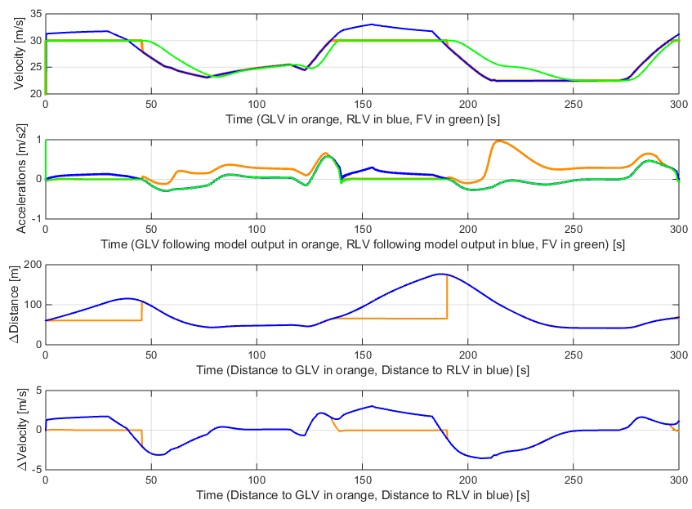
Figure 10: 30 m/s GlvACC example with PrARX car following model.

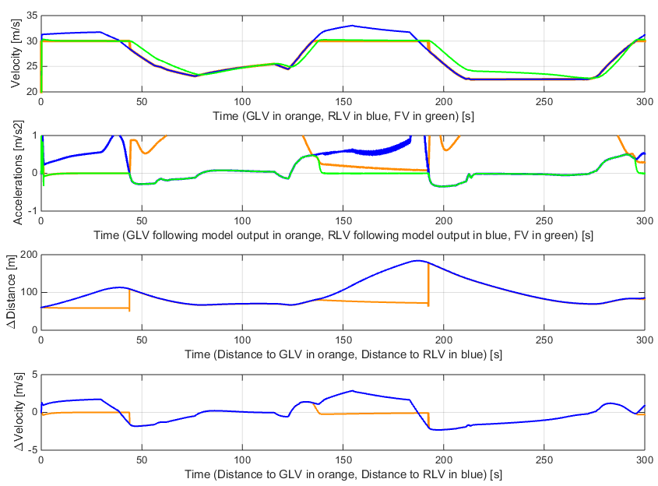
Figure 11: 30m/s GlvACC example with modified GHR car following model

We can see on figures Figure 10 and Figure 11 that both following models are able to handle soft switching conditions without any issue. For t=[0, 40] and t=[130, 190] seconds, ACC model is following the ghost vehicle, otherwise, it is following the real leading vehicle. The lead following vehicle can be understood by looking at the relative distance graph. The model response in green on the acceleration curve differs slightly but the global behavior of the vehicles are similar. There is no major discontinuity due to the lead vehicle switch, the obtained results can be considered as satisfying.

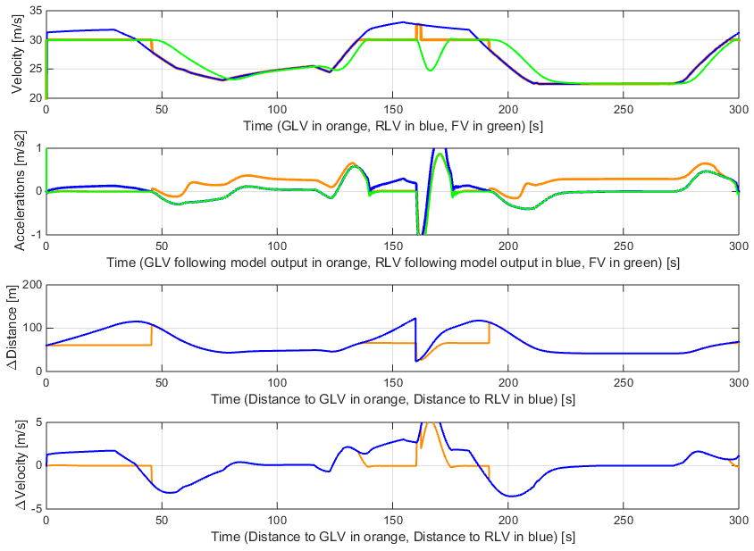
Figure 12: 30m/s GlvACC with PrARX following model, 'Hard RLV in' at t=160s.

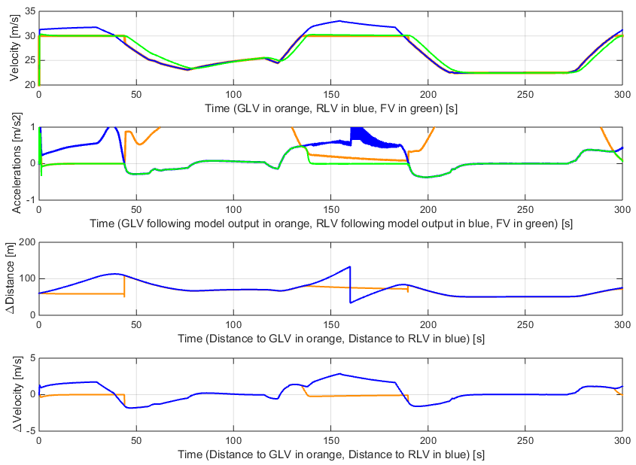
Figure 13: 30m/ GlvACC with modified GHR model, 'Hard RLV in' at t=160s.

Figures Figure 12 and Figure 13 expose the response of the models to the insertion of a RLV during a GLV following phase, at t=160s. We can see that the PrARX based GlvACC responds correctly, by decelerating the vehicle to keep a correct safety distance. In the case of the GHR based GlvACC, we can see that no measure is taken by the model to insure a correct safety distance. It shows that the RLV insertion has not been detected, and the “Hard flow in” case has not been triggered. This is due to the conception of the GHR model, based on the differential velocity divided by the differential distance. This model cannot handle lead car position discontinuities to adapt the following vehicle behavior. The GHR model is not a good candidate for the GlvACC.
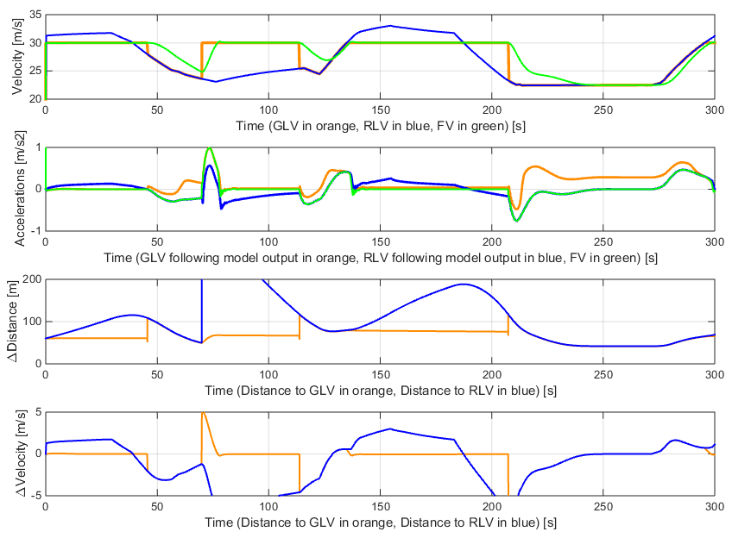
Figure 14: 30 m/s GlvACC with PrARX model, 'Hard RLV out' at t=70s.

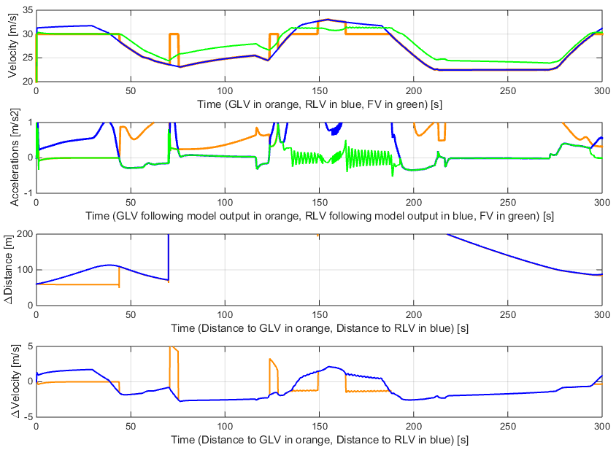
Figure 15: 30m/s GlvACC with modified GHR model, 'Hard RLV out' at t=70s.

Figures Figure 14 and Figure 15 expose the exit of a RLV at t=70s. This case can represent the departure of the leading vehicle from the highway. The PrARX based model react in a logical manner, by following the GLV. In the other hand the GHM based model does not handle the situation correctly. This is due to the fact than despite the distance separating the following car and the RLV, the model output is lower for the RLV following than the GLV following. Thus the models switches back to RLV following mode and the result becomes meaningless.

We could observe in the previous comparison that the logic switching has to be adapted to the selected following model. The switching logic has been developed based on human reactions, The PrARX car following model can be correctly reproduce human reactions, and therefore lead to a coherent model behavior. Nevertheless, the GHR model is not adapted to the iteration of the GlvACC. Adaptation to the cruise control logic would have to be done to insure correct situation selection.

- ACC model comparison

IDM model
http://www.akesting.de/download/ACC_TRR_2007.pdf

$$\dot{v}\left(s,v,∆v\right)=a\left[1-{\left(\frac{v}{v_{0}}\right)}^{4}-{\left(\frac{s^{*}\left(v,∆v\right)}{s}\right)}^{2}\right]$$
$$s^{*}\left(v,∆v\right)=s_{0}+vT+\frac{∆v}{2\sqrt{ab}}$$

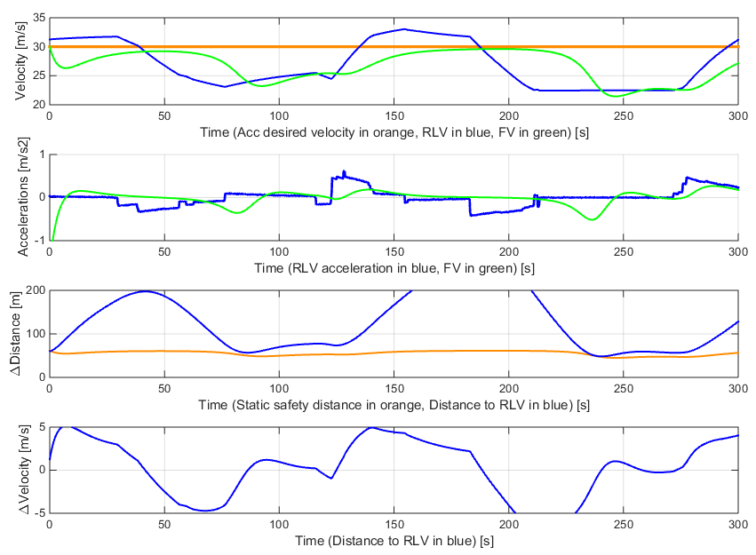
Figure 16：Following situation with the IDM algorithm.

Description | Desired velocity [m/s] | Jam distance [m] | Safety time [s] | Maximal acceleration [m/s2] | Desired deceleration [m/s2]
Variable | $$v_{0}$$ | $$s_{0}$$ | $$T$$ | $$a$$ | $$b$$
Value | 30 | 2 | 2 | 1.4 | 2
Table 2: Model's parameters values

Gipps model

$$v\left(t+t_{reac}\right)=\min\left\{\begin{matrix}v\left(t\right)+2.5a_{max}t_{reac}\left(1-\frac{v\left(t\right)}{v_{0}}\right)\sqrt{0.025+\frac{v\left(t\right)}{v_{0}}} \\ bt_{reac}+\sqrt{b^{2}t_{reac}^{2}+b\left[2\left(∆x\left(t\right)+s_{0}\right)+v\left(t\right)t_{reac}+\frac{v_{lead}{\left(t\right)}^{2}}{b_{max}}\right]}\end{matrix}\right\}$$

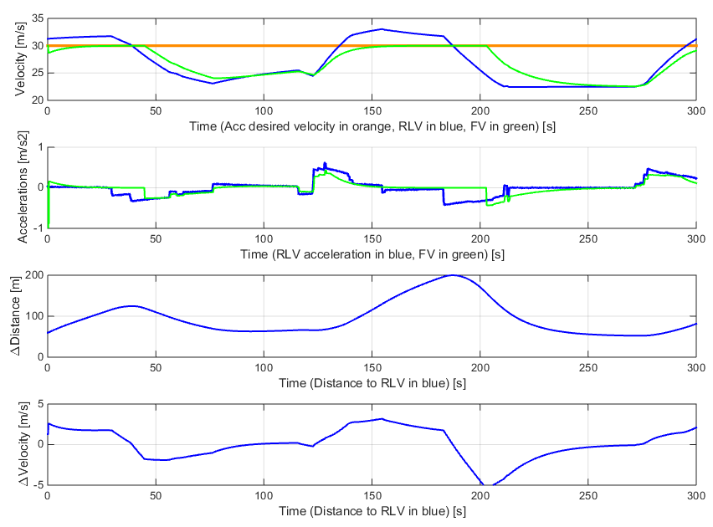
Figure 17: Following situation with the Gipps model

Description | Desired velocity [m/s] | Stop distance to lead vehicle head [m] | Reaction time [s] | Maximal acceleration [m/s2] | Desired deceleration [ms2] | Maximal deceleration [m/s2]
Variable | $$v_{0}$$ | $$s_{0}$$ | $$t_{reac}$$ | $$a_{max}$$ | $$b$$ | $$b_{max}$$
Value | 30 | 5 | 0.3 | 1.5 | 1.5 | 2.5

- Real world application proposition
Explain low cost of the structure, of the following models.
And the PrARX.
- Conclusion

